IT24101987

Ps lab 7

Exercise

Question 1: Uniform Distribution

A train arrives at a station uniformly between 8:00 a.m. and 8:40 a.m. Let the random variable X represent the number of minutes the train arrives after 8:00 a.m. What is the probability that the train arrives between 8:10 a.m. and 8:25 a.m.?

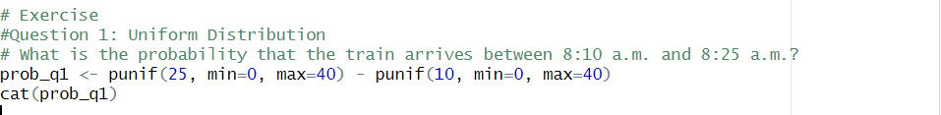



Question 2: Exponential Distribution

The time (in hours) to complete a software update is exponentially distributed with rate λ = 1 /3 . Find the probability that an update will take at most 2 hours

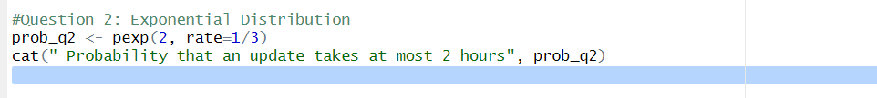



Question 3i: Normal Distribution

Suppose IQ scores are normally distributed with a mean of 100 and a standard deviation of 15.

1. What is the probability that a randomly selected person has an IQ above 130?

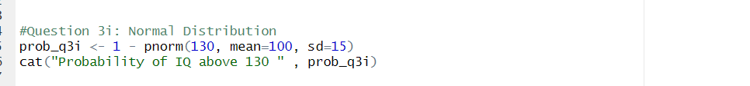



ii.) What IQ score represents the 95th percentile?

